SMT. PARAMITA BANDYOPADHYAY

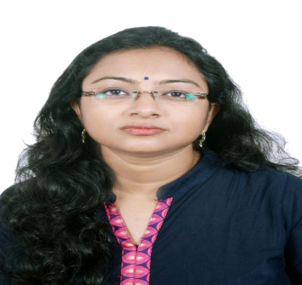
Mobile: +919433381287
+919051837372
Email:paramitaband@rediffmail.com

SUMMARY
- 9+ years of teaching experience.
- Currently working as Govt. approved part time teacher in English at Naba Barrackpur Prafulla Chandra Mahavidyalaya, Kolkata since 2009.
- Good experience of working as a member of college cultural sub-committee.
- Experienced in Preparing Question Papers for internals during test exams.
- 5+ years of experience of examiner of University exams.
- Possesses good communication, interpersonal and leadership skills
- Academic Counsellor of English at IGNOU & NSOU.
- Delivered lectures on literary topics in the distance education P.G. course conducted by Vidyasagar University.
- Delivered lectures in English at Rabindra Bharati University for the candidates appearing for competitive exams conducted by UGC.
- Worked as an Anchor at IGNOU Interactive Radio Counselling Programme on the Subject “Foundation Course in English I & II (FEG- 01 & FEG- 02).

Professional Experience:

Govt. approved part time teacher in English.

Naba Barrackpur Prafulla Chandra Mahavidyalaya.

August 2009 – Till Date

EDUCATION

Pursuing Ph.D., Kazi Nazrul University

M. Phil, Rabindra Bharati University, 2010

B.ED, Calcutta University, 2008

M.A, Rabindra Bharati University, 2005

B.A (English Hons.), Calcutta University, 2003

Paramita Bandyopadhyay(Govt. approved P.T.T. in English) M.A., M.Phil., B.Ed. is pursuing her Ph.D. degree on select plays written by two Indian English women playwrights. In her M.Phil.dissertation, she has dealt with the aspect of family relationships as depicted in some of the plays of Mahesh Dattani, a front-ranking Indian English playwright. While devoted to academic pursuits, she is thoroughly engaged in literary and cultural activities. She participates in literary seminars by way of reading papers and also joins in interactive sessions. An associate of Shakespeare Society of Eastern India and a regular cultural activist, she excels in the rendition of Rabindra Sangeet. As a drama enthusiast, she regularly watches dramatic performances by the Indian and Foreign troupes. She is an ardent follower of progressive ideas.

Seminar Participation, Presentation, Workshops and Conferences

RECENT PUBLICATION:

Article on Vijay Tendulkar’s play Kamala, published in ‘Panchakot’, an ISSN Journal.

Article on Vijay Tendulkar’s play Silence! The Court is in Session provisionally accepted for publication in Middle Flight,Vol.7, an ISSN Journal.

SEMINARS/WORKSHOPS ATTENDED:

- Presented paper on “Oitihya o Adhunikata:Teen dharar Bangla Natok” in an international seminar titled “Bangla Natok: Oitihya o Adhunikata” at Rabindra Bharati University.

2. Participated in an International Seminar titled “Tagore and Woman”organised by the Department of English, West Bengal State University.

- Participated in World Shakespeare Conference organised by Rabindra Bharati University in collaboration with Tagore Gandhi Institute.

- Presented paper on the Women Question as represented in a Bengali Novel titled
Gandhorbi by Bani Basu.

PERSONAL

Residence
HB-320, SECTOR-3, SALTLAKE,
KOLKATA-700106

Date of Birth: Feb 18, 1983

