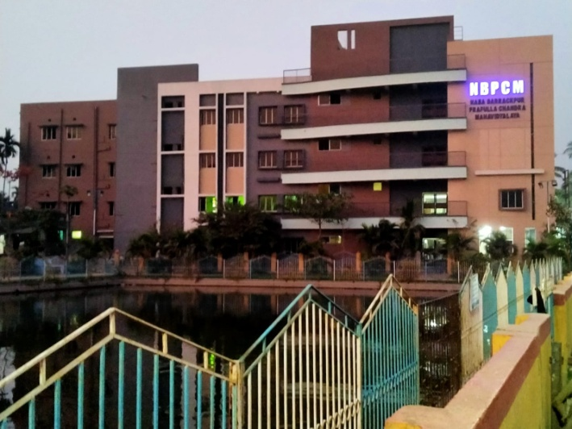  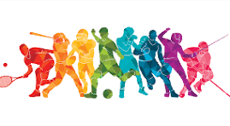 | 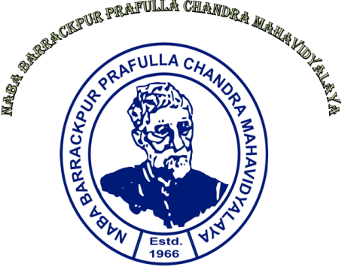  Activity Report of Sports -2024-25  Sports Sub-Committee  Naba Barrackpur Prafulla Chandra Mahavidyalaya  New Barrackpore, Kolkata-700131

Activity Report of Sports -2024-25
Introduction
Physical activities are essential key for ensuring better mental and physical heath of human being. Better physical and mental health not only helps one to live a healthy life but also ensure one’s self progress or development. Participation and Involvement in physical activities such as sports events by the students have, therefore, been given special emphasis and included in the curriculum in all the higher educational institutions. Keeping this view in mind, the Sports Sub-committee of the Naba Barrackpur Prafulla Chandra Mahavidyalaya takes initiative to encourage the students of the college to take part in different inter-college and inter-university sports championships and organizes annual sports meet of the college every year.
The present report portrays the sports activities/programmes conducted by the Sports Sub-Committee of the college during the academic year -2024-25. Particularly, This report portrays the report of participation of students of our college in different inter-college and inter-University sports championships as well as annual sports meet in the academic year 2024-25. A detail report on the sports activities/events for the academic year 2024-25 is presented below.
- Event report of the Inter-college/Inter-University Sports Championships:
- Inter-college men’s and women’s badminton championship
Date: 03/10/2024 Venue: Bhairab Ganguly College
A total of 2 students (boys) had participated in the inter-college badminton championship held at and organized by Bhairab Ganguly College, headed by West Bengal State University on 03/10/2024. Professor Sujit Patra, Dept. of Physical Education had led the team as both the team coach and team secretary. Some photographs in support to this are presented below.

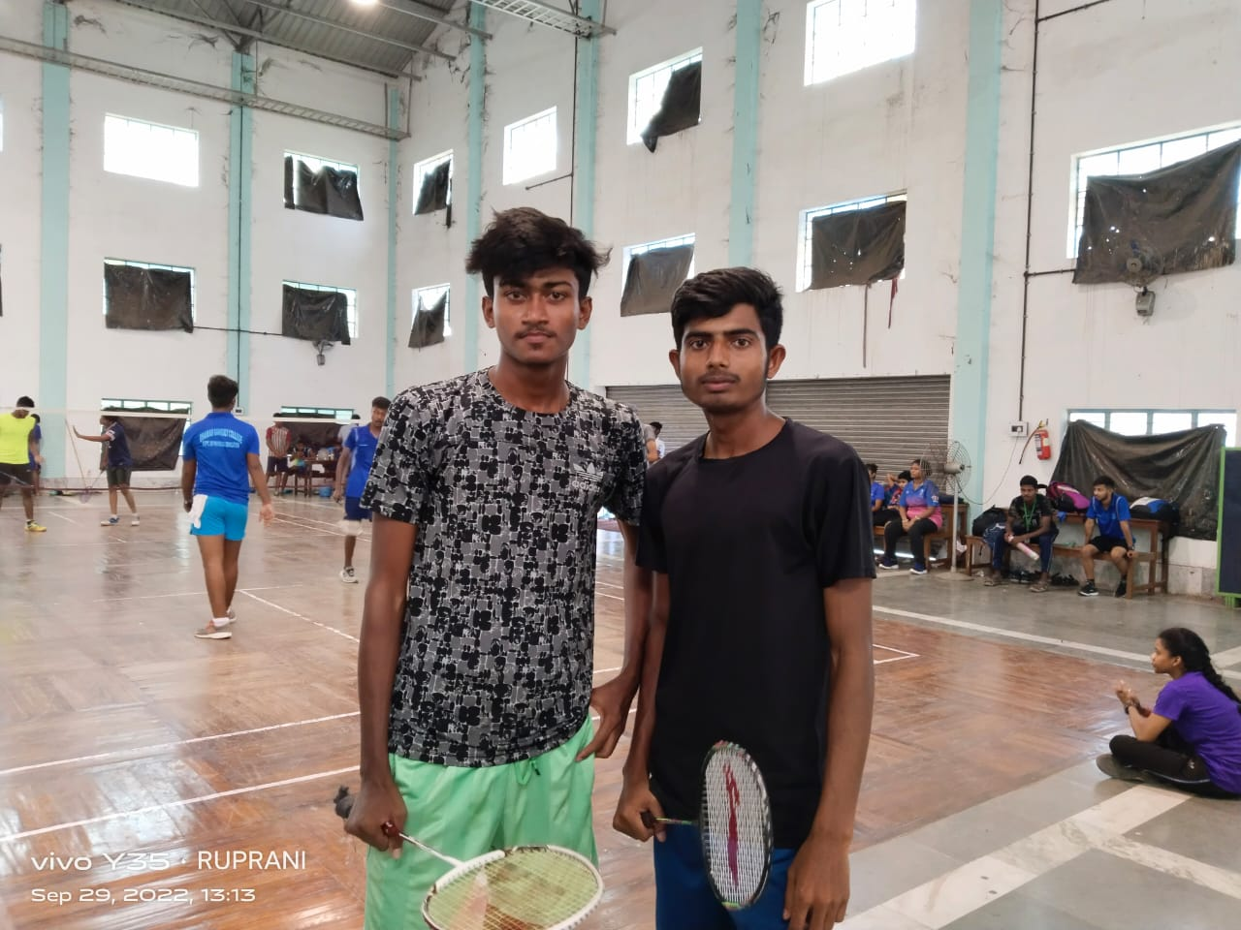
Participation of students of NBPCM in inter-college badminton championship-03/10/2024

- Inter-college men’s football championship
Date: 07/11/2024-11/11/2024 Venue: Rishi Bankim Chandra College & Kalyani
Stadium
The Inter-college Men’s football championship/tournament was held at and organized by Rishi Bankim Chandra College, headed by West Bengal State University during 07/11/2024-11/11/2024. A group of 18 students of various departments of our college participated in that championship. This event were held at both Rishi Bankim Chandra College play ground, Naihati, North 24-Parganas and Kalyani stadium, Kalyani, Nadia. Dr. Malay Das, Dept. of Economics, Sri Sujit Patra, Dept. of Physical Education, Sri Kartik Chandra Khan, Dept. of Education and Sri Soumen Ghosh, Dept. of Psychology had led the football team as the coach and secretary alternatively in alternative days of this event championship. Two photographs in support to this are presented below.

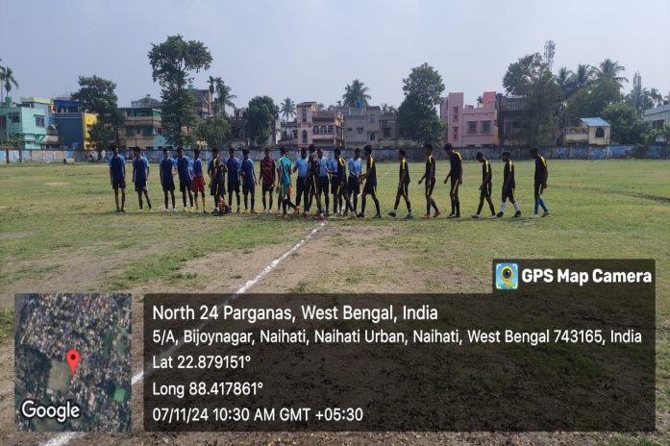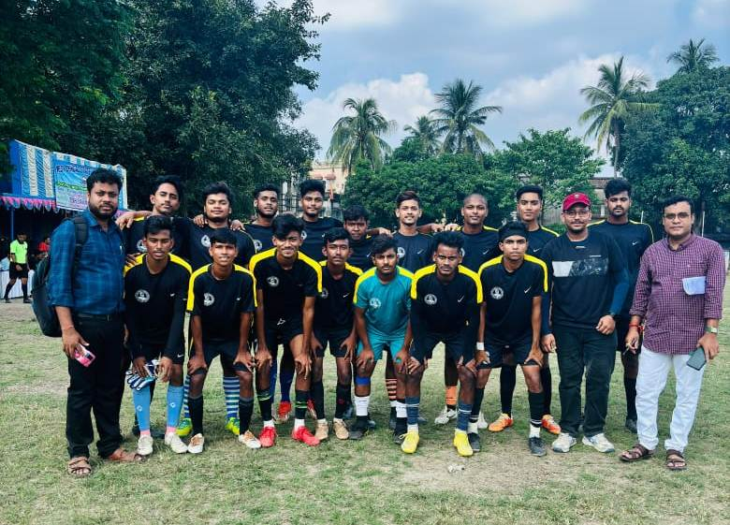
Football team of NBPCM participated in Inter-college men’s football Championship-07/12/2024-11/12/2024

- Inter-college men’s cricket tournament
Date: 16/12/2024 Venue: Hiralal Majumder Memorial College for Women
The inter-college men’s cricket tournament was organized by Hiralal Majumder Memorial College for Women, Dakshineswar, North 24-Parganas, headed by West Bengal State University, held during 16/12/2024-20/12/2024. The organizing college conducted this event at Khardaha Football ground, North 24-Parganas. A team of 11 students (boys) from our college actively participated in that tournament. Sri Arup Sen, Dept. of Psychology and Sri Tanumoy Brahma, Dept. of History from our college had led the team as the team coach and secretary, respectively in the said tournament. Two photographs in support to this are presented below.

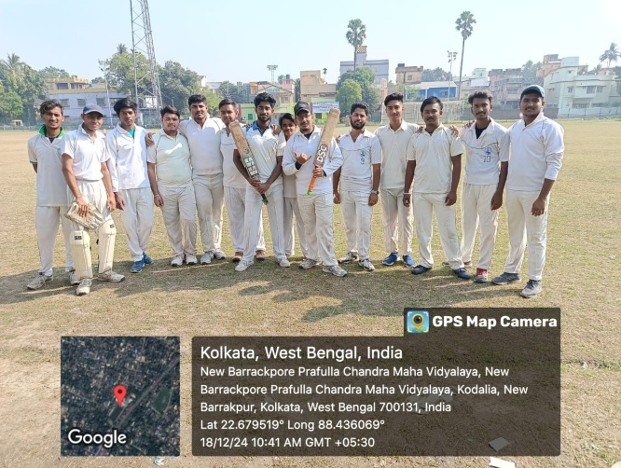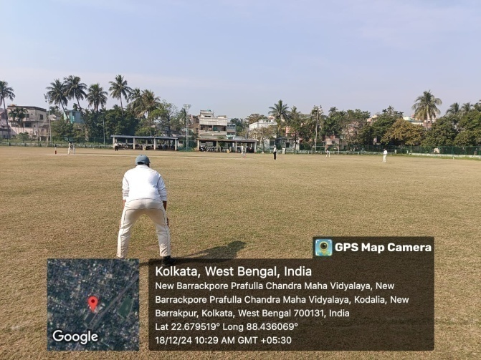
Participation in the inter-college cricket championship, 18/12/2024

- Inter-college men’s Athletics (100 mtr and 200 mtr run)
Date: 10/12/2024 Venue: Saltlake Stadium, West Bengal State University
Four students (boys) from our college actively participated in the Inter-college Athletic competition held during 10/12/2024-12/12/2024 at Saltlake Stadium, Kolkata. This even was organized by our home university- West Bengal State University, Berunanpukuria, Barasat, North 24-Parganas. Two photographs in support to this are presented below.

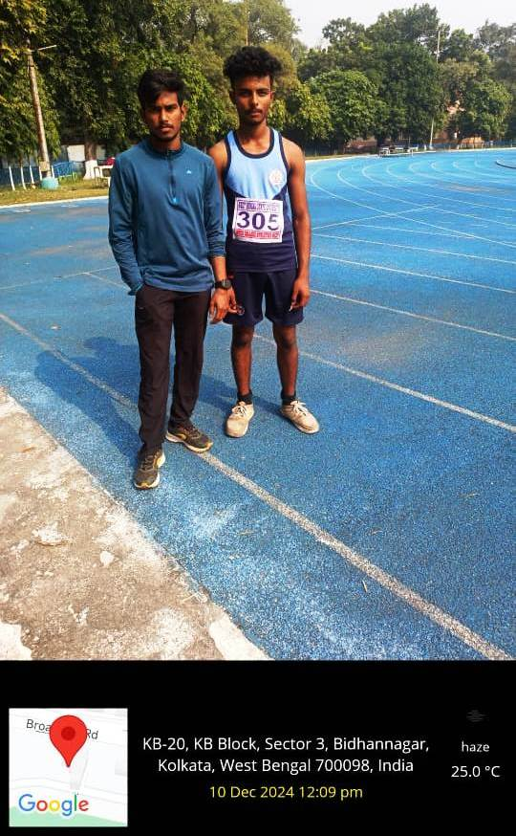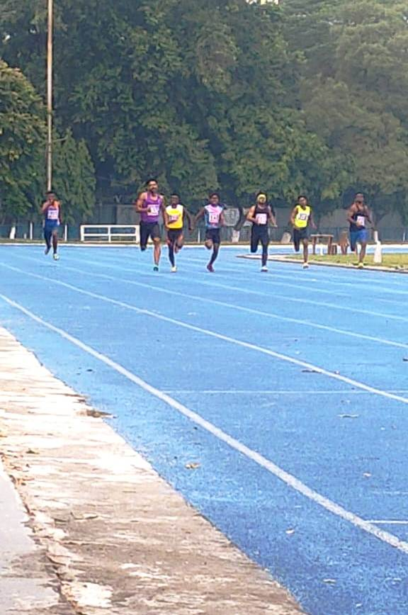
Participation in the Inter-college Athletic Competition-10/12/2024-12/12/2024

- Event Report of Inter-Departmental Sports Meet-2024-25
Inauguration
Date: 31/01/2025 Venue: NBPC College Premises
The inter-departmental sports meet was organized by the Sports Sub-Committee of the college during 10-11 January, 2025. The inauguration ceremony of the inter-departmental sports meet was conducted by Sri Sujit Patra, Jt. Convenor, and Sri Gobinda Chandra Das, Sri Arup Sen and Sri Tanumoy Brahma, the members of Sports Sub-Committee of the college. It was started with the flag hoisting of the college and by lightening the lamp. The flag was hoisted by Dr. Sunil Kumar Biswas, Hon’ble Principal of the college. The lamp was lighten also by the Hon’ble Principal. Then Prof. Swapan Kumar Giri, Hon’ble Bursar of the college and other teachers also joined the programme of lightening the lamp. After then, the Hon’ble Principal was invited to deliver the inaugural speech. In his inaugural speech, Hon’ble Principal mention the importance of sports activity and also encouraged the sports sub-committee for organizing inter-departmental sports meet. He also encouraged all students to take part in that sports meet. Many teachers, Non-teaching staff and students were present in and joined that inaugural ceremony of inter-departmental sports meet. Two photographs in support to this are given below.
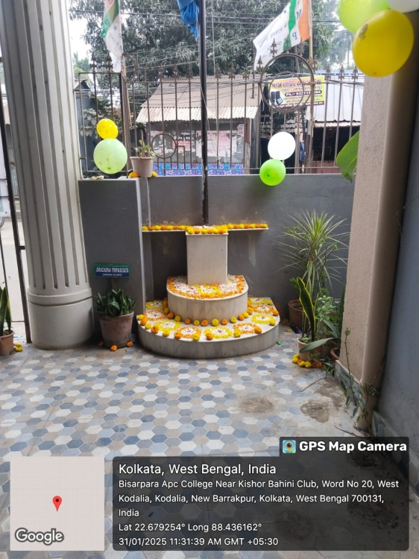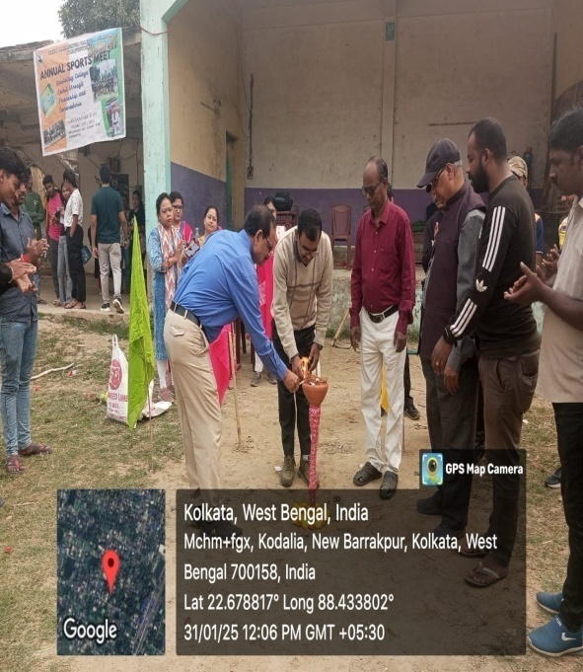

Under this sports meet 2024-25, both indoor and outdoor games/events were organized. The outdoor and indoor games were organized on 31st January, 2025 and 1st February, 2025, respectively. About 52 (fifty two) students and 12 (twelve) students from different semesters actively participated in different outdoor-game competitions and indoor-game competitions, respectively. The detail report of the inter-departmental sports meet of 2024-25 is presented below.

- Event report Outdoor games
Date: 31/01/2025 Venue: Playground, NBPCM
100 & 200 meter run:
A total of 11 students (6 men and 5 women) from different semesters actively participated in 100 meter and 200 meter race competitions. Dr. Touhid Hossain, Sri Khitish Bhatta, Sri Gobinda Chandra Das, Sri Arup Sen and Sri Sujit Patra were the judges for this event competition. Two photographs in support to this are presented below.

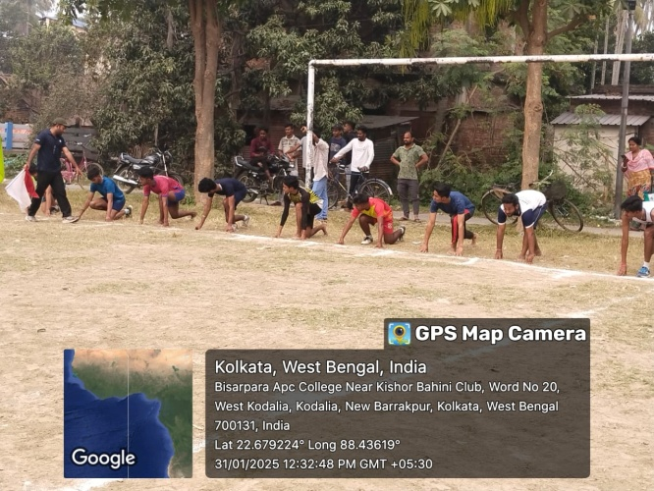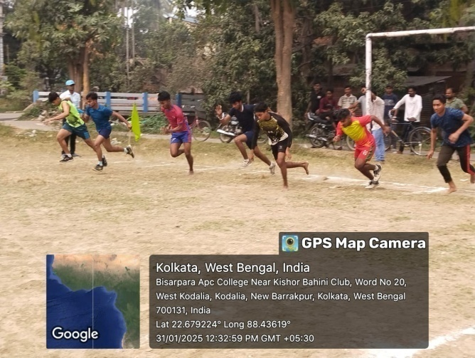
100 & 200 meter race competition, Men
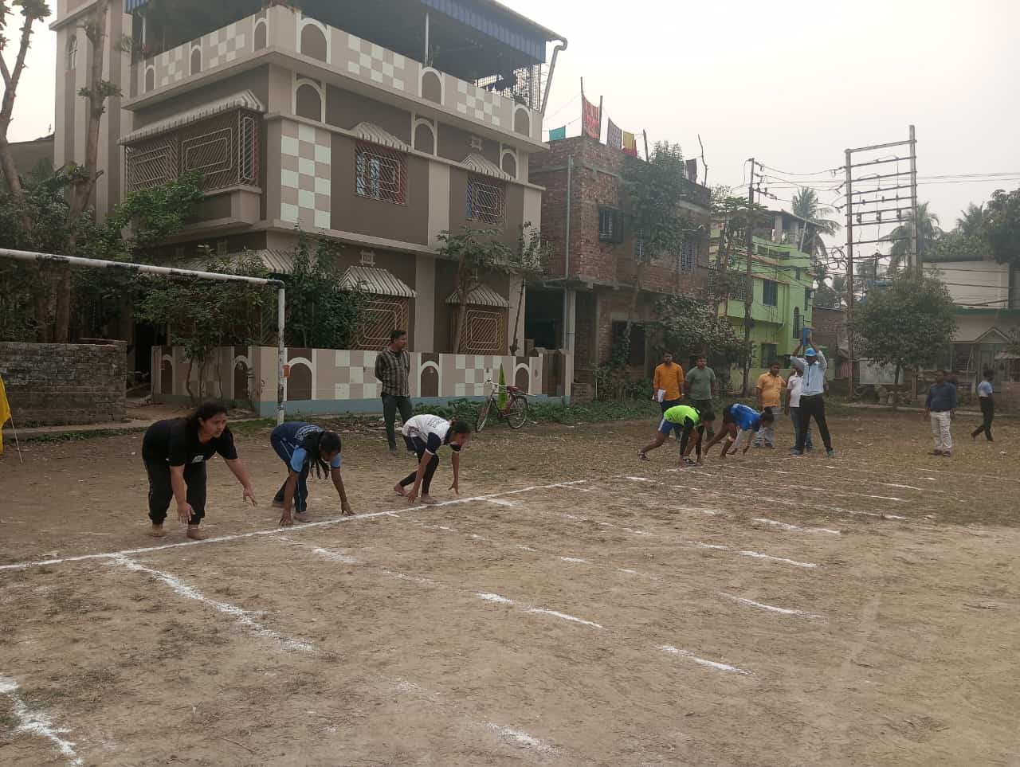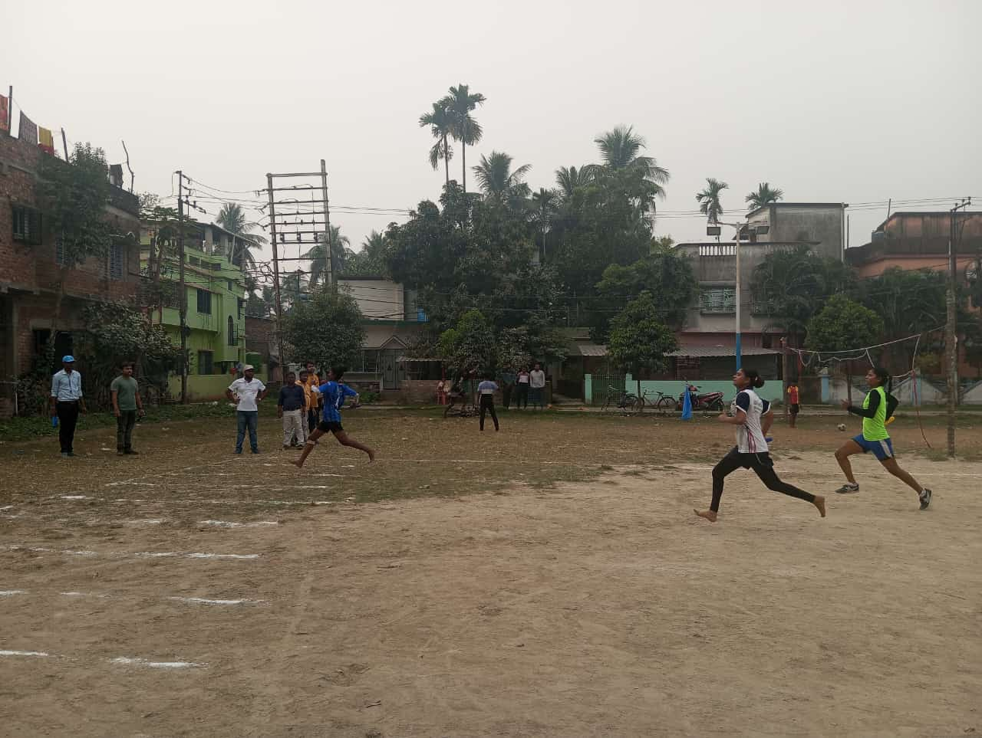
100 & 200 meter race competition, Women
Shot-put throw competition
Six (6) students (3 men and 3 women) from different semesters actively participated in shot-put throw competition. Dr. Touhid Hossain, Sri Khitish Bhatta, Sri Gobinda Chandra Das, Sri Arup Sen and Sri Sujit Patra were the judges for this even competition. Two photographs in support to this are presented below.
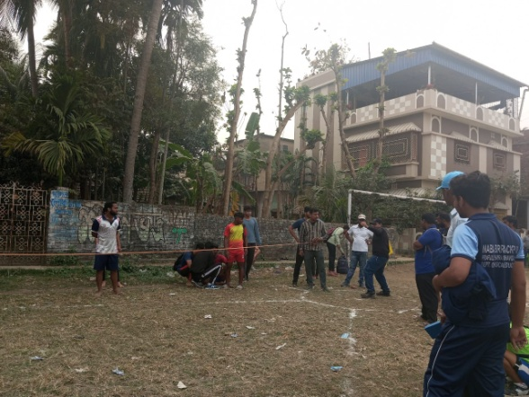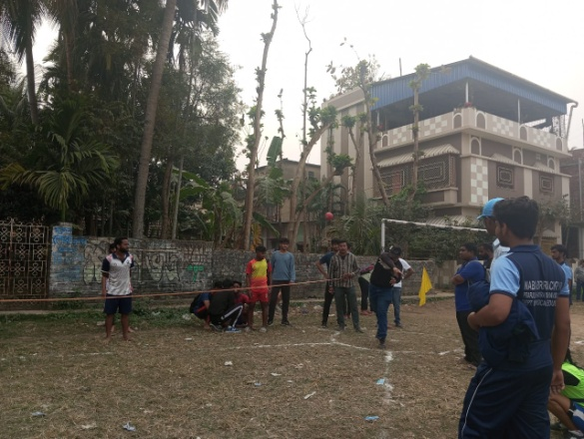
Shot-put throw competition, Men

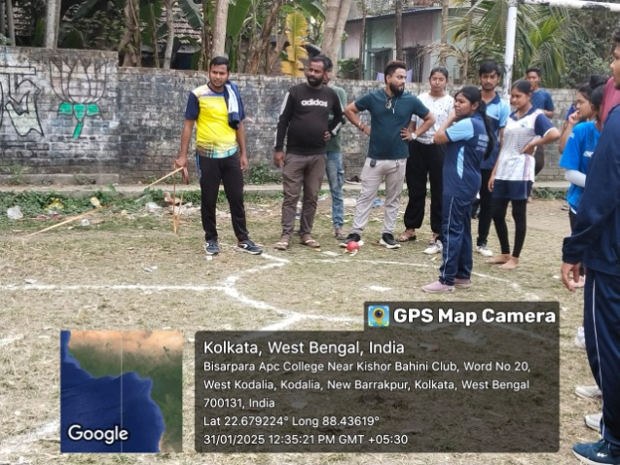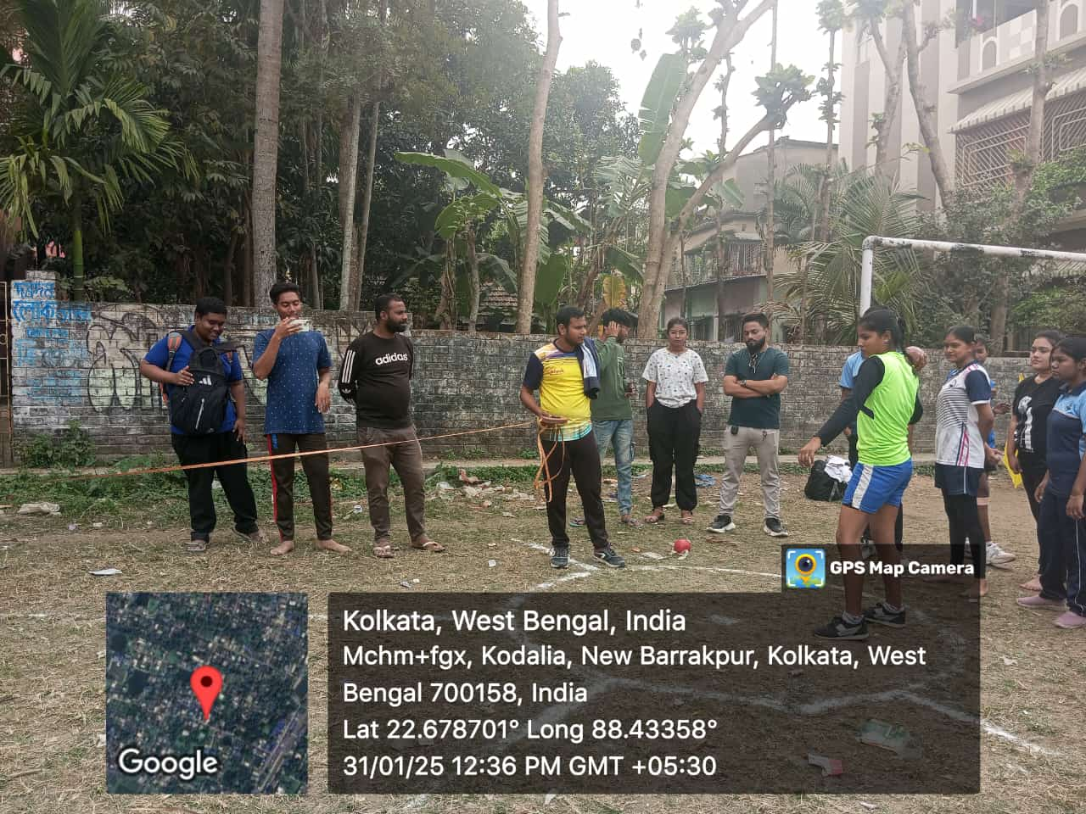
Shot-put throw competition, Women
Javelin Throw Competition (men and women)
Six (6) students (3 men and 3 women) from from different semesters actively participated in Javelin throw competition. Dr. Touhid Hossain, Mr. Khitish Bhatta, Mr. Arup Sen, Mr. Swapan Kumar Maiti and Sujit Patra were the judges for this even competition. Two photographs in support to this are presented below.
………………………..picture
Javelin Throw Competition
Inter-departmental Volleyball-play Competition (men)
Four (4) volleyball teams comprising a total of 28 students from different semesters of the college actively participated in the volleyball play competition. These teams were classified as- Group A, Group B, Group C and Group D. Out of these four groups, Group A and Group D became the winner and runner, respectively. Mr. Sujit Patra, Mr. Arup Sen, Mr. Swapan Kumar Maiti were the judges for this event. Two Photographs in support to this are presented below.
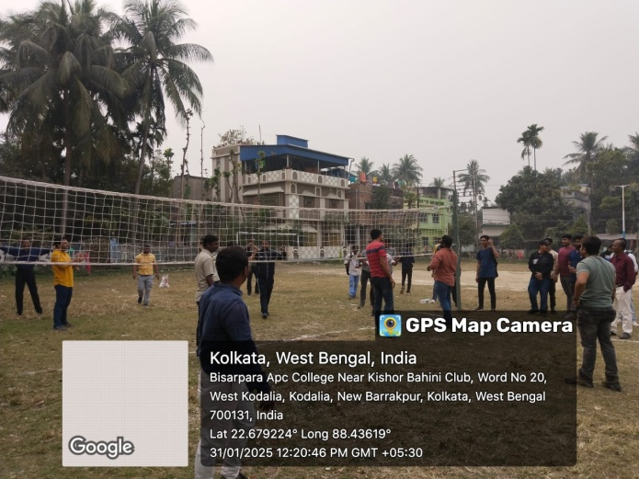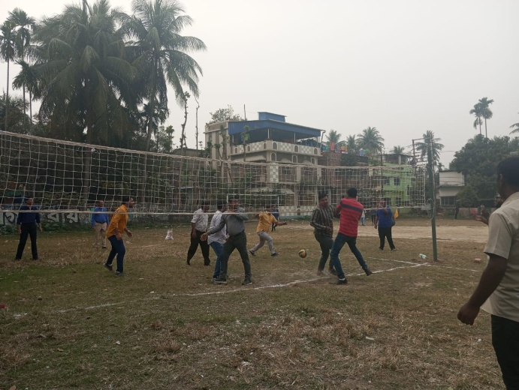
Volleyball-play competition, Men

- Event report of inter-departmental indoor games
Date: 01/02/2025 Venue: NBPCM Premises
Chess Competition
Three students (boys) from different semesters/courses actively participated in the chess competition. However, no girl participated in that event. Mrs. Mallicka Banerjee, Mrs. Rama Sarkar and Mr. Bikram Ghosh were the judges for this event. Two photographs in support to this are presented below.
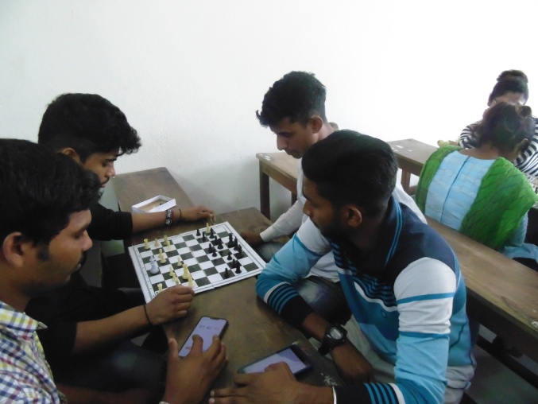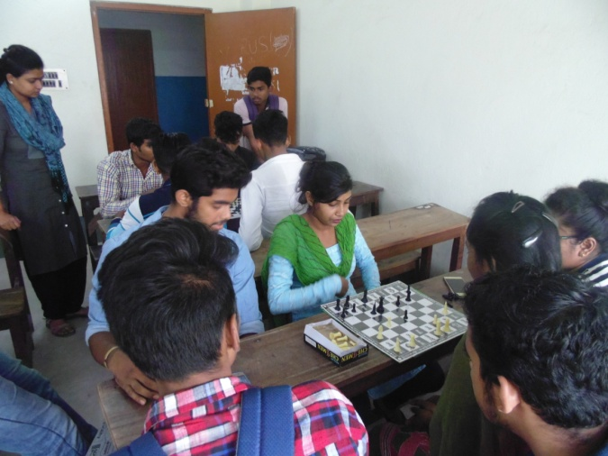
Chess Competition

Badminton-play competition (men and women)-Single
Six students (three boys and three girls) from different semesters/courses actively participated in the badminton play competition. Mr. Subhankar Naha, Mr. Soumen Ghosh, Mr. Sujit Patra and Mr. Shanu Das were the judges for this event competition. Two photographs in support to this are presented below.
………………picture
Badminton-play competition
Table Tennis-play competition (men)
Three students (boys) from different department actively participated in the event of table tennis competition. Three students were selected for three positions- 1st, 2nd and 3rd from this event. Mr. Sujit Patra, Jt. Convenor of sports and Mr. Soumen Ghosh, Dept. of Psychology were the judges for this event. Two photographs in support to this are presented below.
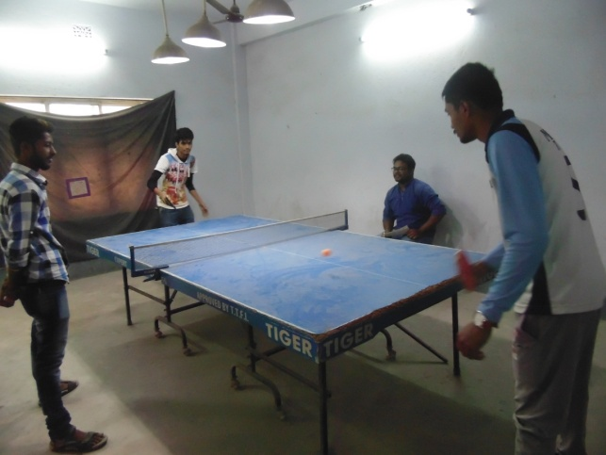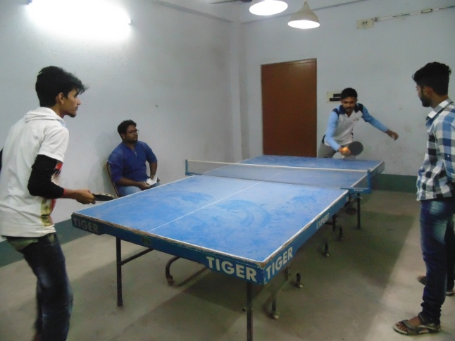
Table Tennis Competition

- Prize distribution ceremony of Annual Sports-2023-24
Date: 01/01/2025 Venue: NBPCM Seminar Hall
The Sports Sub-committee of the college had organized the prize distribution ceremony for the Annual Sports Meet-2024-25 in the seminar hall of the college on 01/02/2025. Hon’ble Principal of the college-Dr. Sunil Kumar Biswas, was invited and present in that prize distribution ceremony. All Teaching and Non-teaching staff, and many students including all student participants of the inter-departmental sports meet were also present in that ceremony. This programme was conducted by Mr. Sujit Patra, Jt. Convenor of Sports Sub-committee of the college. Two photographs in support to this are presented below.

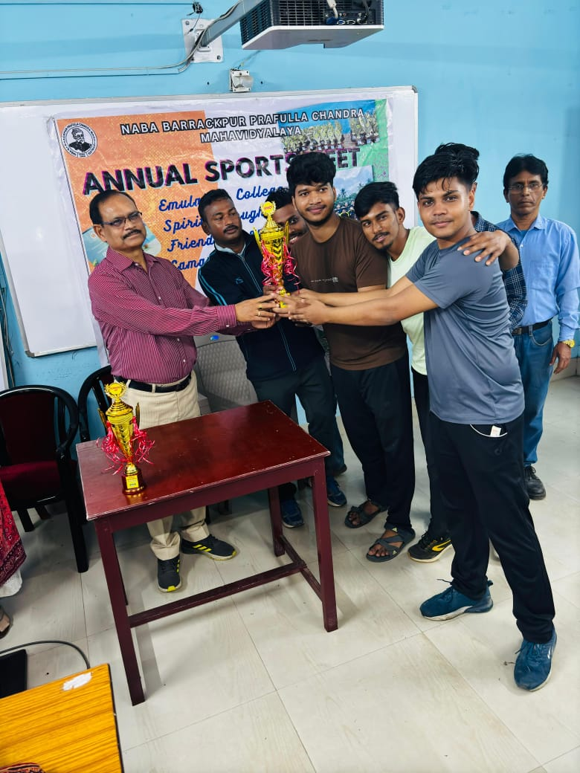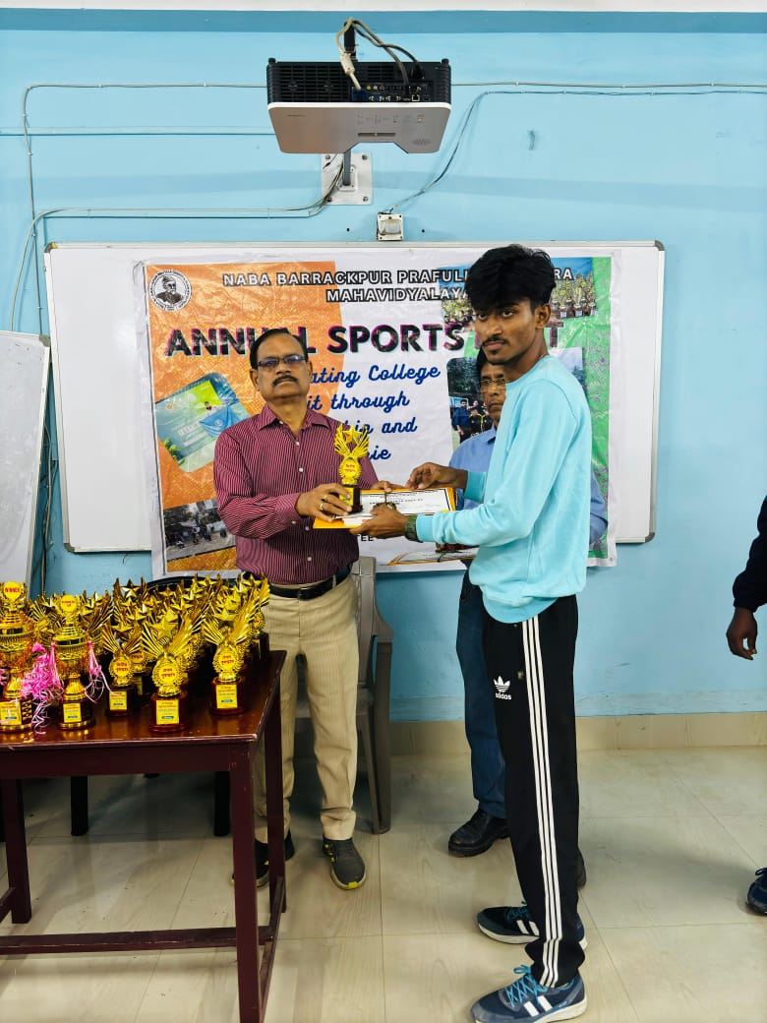
Prize Distribution Ceremony, Inter-Departmental Sports Meet-2024-25

Naba Barrackpur Prafulla Chandra Mahavidyalaya
ANNUAL SPORTS MEET-2024-25
Date: Jan 31 – Feb 1 (Friday & Saturday), 2025
Organized by
Sports Sub-committee
Programme Schedule
Day 1- 31.01.2025 (Friday):
- Inauguration and Flag Hoisting- to be conducted by – Ekramul Hauque Chaudhury, Sujit Patra and Arup Sen

- Flag to be hoisted by- Dr. Sunil Kumar Biswas, Hon’ble Principal, NBPC Mahavidyalaya (Venue- NBPCM Campus)
(11.00 am – 11.15 am)

- Organization and execution of Outdoor events (100 & 200 mtr run, Javelin throw, Shot-put throw & Volleyball)
Special event for Male teachers and NTS: Volleyball

Venue- Paschim Kodaliya Play Ground
(11.30 pm – 3.00 pm)

(Food Coupon distribution: 12.00 noon onwards)
Day 2 – 01.02.2025 (Saturday):
- Organization and execution of Indoor Events (Badminton, Table Tennis, Chess)
Special event for Lady teachers and NTS: Musical Chair

Venue: College Campus

(11.00 am – 4.00 pm)

- Prize distribution
(4.30 pm onwards)

Conclusion and Thanks Giving- Sujit Patra, Jt. Convenor of Sports/Arup Sen, Gobinda Ch. Das (Members)

Dr. Malay Das  Sujit Patra  (Jt. Convenors of Sports) | Dr. Sunil Kumar Biswas  Principal
Naba Barrackpur Prafulla Chandra Mahavidyalaya
Events, Activity & Duty Chart
Annual Sports 31st Jan & 1st Feb, 2025
Date & Time | Game type/Activity/Duty | Events | Judges/Assigned Teachers & Staff
31-01-2025 (Friday), 11.00 am | Outdoor | Shot-Put Throw | Touhid Hossain, Khitish Bhatta, Arup Sen, Sujit Patra, Nishan Chatterjee, Swapan Kumar Maiti (Referee)
31-01-2025 (Friday), 11.00 am | Outdoor | Run (100 & 200 mtr) | Touhid Hossain, Khitish Bhatta, Arup Sen, Sujit Patra, Nishan Chatterjee, Swapan Kumar Maiti (Referee)
31-01-2025 (Friday), 11.00 am | Outdoor | Javelin Throw | Touhid Hossain, Khitish Bhatta, Arup Sen, Sujit Patra, Nishan Chatterjee, Swapan Kumar Maiti (Referee)
31-01-2025 (Friday), 11.00 am | Outdoor | Volleyball | Sujit Patra, Arup Sen, Swapan Kumar Maiti (Referee)
01-02-2025 (Saturday), 11.00 am | Indoor | Chess | Mallicka Banerjee, Rama Sarkar, Bikram Ghosh
01-02-2025 (Saturday), 11.00 am | Indoor | Badminton (Single/Dubble) | Soumen Ghosh, Subhankar Naha, Shanu Das, Bikram Ghosh
 |  | Table Tennis | Sujit Patra, Soumen Ghosh
31st Jan & 1st Feb, 2025 | Food Packet order/, Food coupon distribution/ First Aid/Photography (Normal and Geo Tagged) | Mukulika Ray, Mousumi Mondal, Moumita Biswas, Kartik Ch. Khan & Nupur Mitra, Partha Debnath, Student Representatives
1st Feb, 2025 | Certificate Preparation | Dr. Sanjit Pal, Dr. Saptadipa Karmakar, Shanu Das
 | Overall Management/Arrangement of Chair, Table, Water Jar | Tanumoy Brahma, Sujit Patra, Govinda Ch. Das, Sourav Das, Sujit Das, Partha Debnath
N.B: All judges and other jobs assigned persons are requested to be present in the college premises on time
Dr. Malay Das, Sujit Patra  (Jt. Convenors of Sports) | 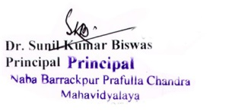

Members of Sports Sub-committee:
- Dr. Sunil Kumar Biswas (Principal/Ex-Officio)
- Dr. Malay Das (Jt. Convenor)
- Sri. Sujit Patra (Jt. Convenor)
- Sri. Gobinda Chandra Das
- Smt. Mukulika Ray
- Sri. Soumen Ghosh
- Smt. Moumita Biswas
- Sri. Arup Sen
- Sri. Panchu Oraon

