DR.SAPTADWEEPA KARMAKAR

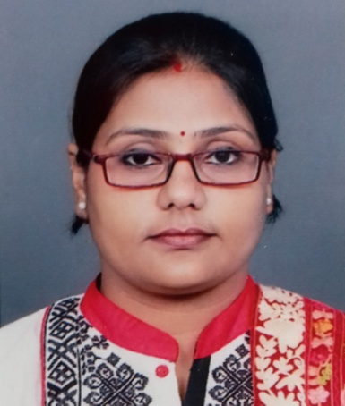
Mobile: +917044075490
+919433744174
Email:saptadweepak@gmail.com
1/3/10, Ramlal Agarwala Lane,
Kolkata 700050

SUMMARY
- 9+ years of teaching experience.
- Currently working as Govt. approved part time teacherin Bengali at Naba Barrackpur Prafullya Chandra Mahavidyalaya, Kolkata since 2009.
- Good experience of working as a member of college cultural sub-committee, NSS subs- committee etc.
- Experienced in Preparing Question Papers for internals during test exams.
- 7+ years of experience of examiner of University exams.
- Possesses good communication, interpersonal and leadership skills

Professional Experience
Govt. approved part time teacher
Naba Barrackpur Prafullya Chandra Mahavidyalaya.
July 2009 – Present

EDUCATION

PursuingPh.D., RabindraBharati University
M. Phil, RabindraBharati University, 2008
M.A, RabindraBharati University, 2006
B.A [Bengali Hons.], Burdwan University, 2004

Seminar Participation, Presentation, Workshops and Conferences
Year : 2010
FEB | Participated in the U.G.C sponsored National Seminar entitled ‘Multiverse of Folcultures: An Eastern Perspective' dated 06/02/2010 organised by Gurudas College in collaboration with Sahitya Akademi, Kolkata.
Year : 2011
FEB | Participated in the seminar entitled 'Anubadbiksha O Rabindranath’ organised by Bankim Chandra Centre for Comparative of Indian Languages & literature, Rabindra Bharati University, Kolkata.
AUG | Participated in the U.G.C sponsored national level seminar entitled 'Somosamoyik Prekkhapot: Rabindranather Prasongikota', dated 26/08/2011, organised by East Calcutta Girls College, LakeTown in collaboration with Rabindra Bharati University, Kolkata.
DEC | Participated and presented paper in the workshop on 'Mythic & Folkloric ingredients in the infra-structure & super-structure of modern literature' held under the auspices of The Asiatic Society from 26th to 31st Dec, 2011.
Year : 2012
JAN | Participated and presented paper in the U.G.C sponsored seminar entitled 'Bangla Sishusahitya: Somoyer Aaynaay' dated 11/01/2012 organised by Dept. of Bengali, Rabindra Bharati University, Kolkata.
OCT | Participated and presented paper on 'Unish Shataker Nirikhe Eka - Ke Gay Oi' in the seminar entitled 'BANKIM CHANDRA O UNISH SHATAK' dated 10/10/2012 organised by Bankim Chandra Tulanamulak Bharatiya Sahitya Charcha Kendra, Rabindra Bharati University, Kolkata.
NOV | Participated and presented paper on'Sishu Sahitye - Rakhal Bhabna' in the U.G.C sponsored seminar in the subject 'Bangla Sishushitya: Somoyer Aaynaay' dated 01/11/2012 organised by Dept. of Bengali, Rabindra Bharati University, Kolkata.
Year : 2013
MAR | Participated and presented paper on 'Prantojoner Kshomotayan - Krittibashi Ramayan ebong Mukundaram Chokrobortir Chondimongal' in the international seminar entitled 'BANGLA SAHITYE PRANTAJON' dated 05/03/2013 organised by Dept. of Bengali, Rabindra Bharati University, Kolkata.
MAR | Participated and presented paper on 'Pathok Rabindranath - Prosongo : Ramayani Kotha' in the seminar entitled 'RABINDRANATH : BHASHANTARE' dated 19/03/2013 organised by Bankim Chandra Centre for Comparative of Indian Studies & Dept. of Hindi & Jorasanko Museum, Rabindra Bharati University, Kolkata.

Year : 2014
JAN | Participated and presented paper on ‘Baishamyahin nari chetanar mashal : Sitayan' in the national seminar entitled ‘Contemporary trends in Indian Literature’ dated 20/01/2014 organised by Dept. of Bengali, Rabindra Bharati University, Kolkata.
MAR | Participated in the U.G.C sponsored international level seminar entitled ‘Bangla Natak : Oitihya O Adhunikata’, dated 04/03/2014, organised by by Dept. of Bengali, Rabindra Bharati University, Kolkata.
Year : 2015
JUL | Participated in the national seminar entitled ‘Comparative Indian Literature’dated 26/06/2015 organised by Bankim Chandra Centre for Comparative of Indian Languages & literature, Rabindra Bharati University, Kolkata
Year : 2016
JUL | Participated in the national seminar entitled ‘Novelist Bankimchandra’dated 28/06/2016 organised by Bankim Chandra Centre for Comparative of Indian Languages & literature, Rabindra Bharati University, Kolkata

Extra-Curricular Activities

- 2nd and 3rd in Recitation and Reading respectively in Inter College competition – SanghatiUtsav[2003-2004], Burdwan University
- 1st Position in District Level Recitation Competition
- Participated in State Level Recitation Competition.

PERSONAL

Residence
1/3/10 Ramlal Agarwala Lane,
Kolkata – 700050

Date of Birth: Jan 01, 1983

